Performance Assessment 1– Syslog, NTP and SNMP

In this lab you will be using Packet Tracer for the lab. You will be using your lab on Span Port and Sniffer and adding to it.

Your network will a class B network based on a number assigned by your professor, which you will be using for the duration of the class. In the lab anytime you see an underline you should fill in this number.

**Student network: 10.____.0.0/16**

**Using the Packet Tracer network you created when doing Span Port and Sniffer, add a second server to the network. This server will be used as your Syslog and NTP server. Give your syslog server the IP address of 10.___.2.11/24 (don’t forget to assign it a default gateway).**

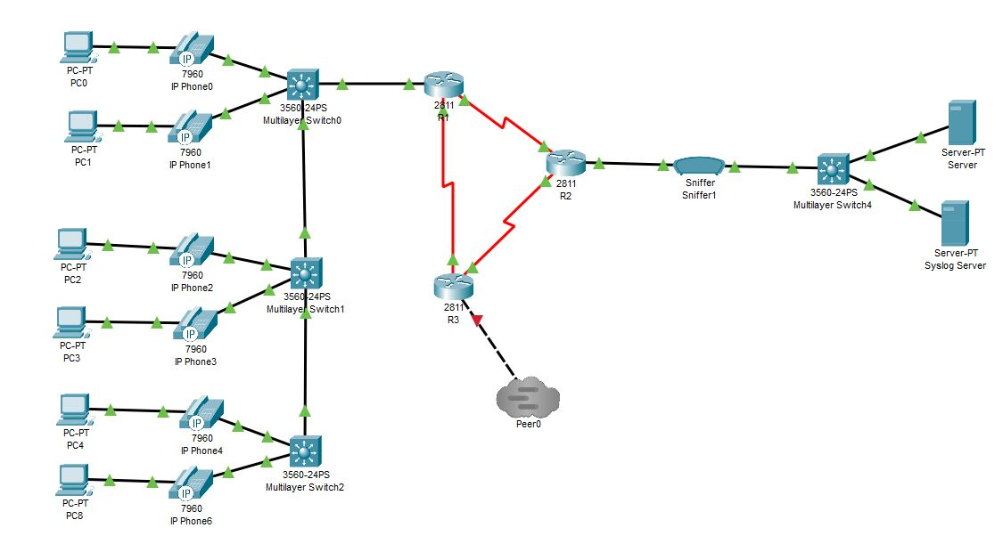

**Task 1 – Add Syslog monitoring to your routers and switches**

Now you are going to set up the syslog service on your server. Click on your server and go to the services tab. Click on Syslog and verify that the service is running.

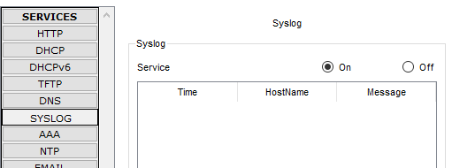

This is the location where all of your syslog information will show in the server.

Now you will go in and configure the R1 router for logging to this server.

Enter the command:

***R1(config)# logging 10.___.2.11***

Disconnect and reconnect your serial cable from R3 to R1.

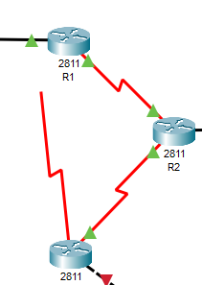

Go back to your R1 console and view your messages generated by this disconnect and reconnect. Take a screenshot.

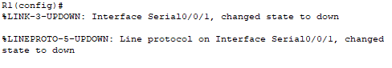

Go to your syslog server and verify that the messages have been logged in the server. Take a screenshot.

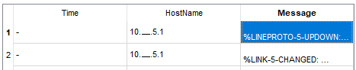

What is being recorded on the server? Why does it only show one IP address? What would you need to do to show both IP addresses affected by the down link between R3 and R1?

**Deliverables**

* Screenshot of your working network
* Screenshot of your syslog server show event
* Answer the questions

PASTE SCREENSHOTS BELOW

**Task 2 – Adding NTP service to your network**

In this task we’re going to add the NTP service to your network using the Syslog server. Go to services tab and click on NTP and activate the service.

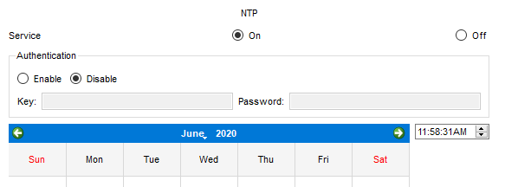

Note the date and time from the service. Add one hour to the service time in the system.



Go into your Syslog and clear the log

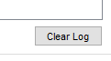

Open your R1 router and type the following:

***R1(config)# ntp server 10.___.2.11***

***R1(config)# service timestamps log datetime msec***

Now let’s test it by turning off your S0/0/1 port and then turning it back on.

***R1(config)# interface s0/0/1***

***R1(config-if)# shut***

***R1(config-if)# no shut***

You will now notice your messages include a timestamp for your messages. Check your syslog. You should now see timestamps in your syslog as well. Note you may need to click away from the syslog tab and back on before you can see the updated log. Take a screenshot of your syslog.

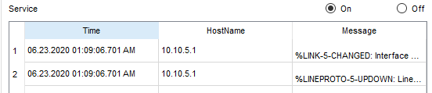

**Deliverables**

* Screenshot of your syslog after applying NTP on R1

PASTE SCREENSHOTS BELOW

**Task 3 – Add SNMP to your network**

Simple network management protocol (SNMP) is used for network monitoring and management. It is made up of three parts, the SNMP manager, SNMP agent, and the management information base (MIB). In this task you will be setting up a server to act as the MIB browser and your routers as SNMP agents.

Go into the R1 router and type the following commands:

R1(config)# snmp-server community R1 ro

R1(config)# snmp-server community R1rw rw

Do the same for R2 and R3:

R2(config)# snmp-server community R2 ro

R2(config)# snmp-server community R2rw rw

R3(config)# snmp-server community R3 ro

R3(config)# snmp-server community R3rw rw

You will also need to add logging for R2 and R3:

***R2(config)# logging 10.___.2.11***

***R3(config)# logging 10.___.2.11***

On your syslog server go to your desktop and open the MIB browser. Click on the advanced button and enter the following. Your read community is R1 and your Write community is R1rw from the commands you entered above. Change your SNMP version to v3. Click the OK button.

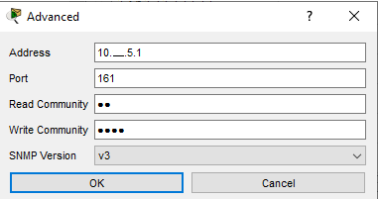

Go back to the MIB browser page and expand the MIB tree by clicking on the arrow to the left



Keep going down the menu tree until you come to .ifDescr and click on it.

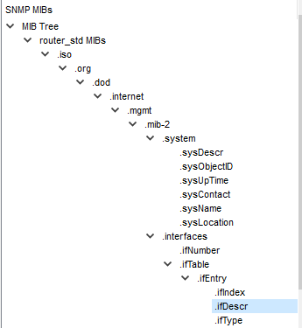

You will now see an OID at the top of the screen. Click on the GO button. Verify that your interfaces are in the MIB database. Take a screenshot.

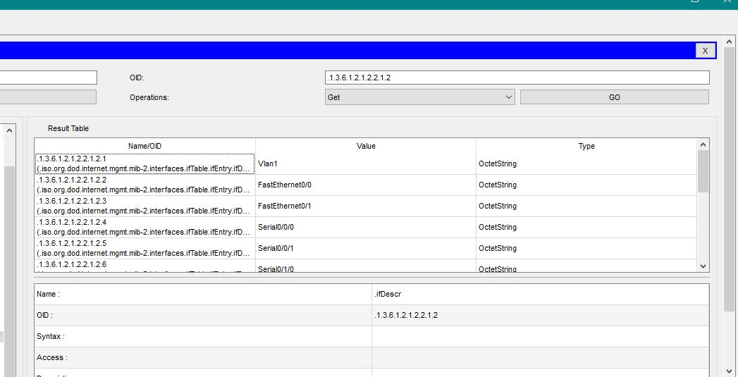

Verify that you can see the information for R2 and R3. Take a screenshot of each. Keep in mind you will have to go back and input the IP address of each device individually in the advanced tab of the MIB browser like you did for R1.

**Deliverables**

* Screenshot of your MIB database for R1
* Screenshot of your MIB database for R2
* Screenshot of your MIB database for R3

PASTE SCREENSHOTS BELOW